1.

List the members of the set Q = {Prime factors of 30}
A.
{2,3,5}
B.
{2,6,10}
C.
{3,5,15}
D.
{3,6,15}

2.

Given that set P = {m,n,o,p}, find the number of subsets of P.
A.
4
B.
8
C.
10
D.
16

3.

If M = {Multiples of 4 between 10 and 25} and N = {even numbers between 11 and 23}, find M∪N.
A.
{12,16,20}
B.
{14,18,22}
C.
{12,14,16,18,22}
D.
{12,14,16,18,20,22,24}

4.

What is the place value of 7 in 24.376?
A.
Unit
B.
Ten
C.
Tenth
D.
Hundredth

5.

Find the Highest Common Factor of 24, 42 and 72
A.
4
B.
6
C.
7
D.
12

6.

Express 120₅ as a number in base 10.
A.
25
B.
27
C.
32
D.
35

7.

If p x q x r = 1197, and p = 19, q = 3, find r.
A.
21
B.
49
C.
57
D.
61

8.

How many integers are within the interval -5 < x < 7?
A.
10
B.
11
C.
12
D.
13

9.

Divide 1.612 by 0.4.
A.
4.3
B.
4.03
C.
0.403
D.
0.43

10.

Arrange the following fractions in ascending order:
5
8
,
11
20
,
7
10
.
A.
5
8
,
11
20
,
7
10
B.
7
10
,
5
8
,
11
20
C.
11
20
,
5
8
,
7
10
D.
5
8
,
7
10
,
11
20

11.

Abena spent
1
5
of her money on sweets,
4
7
on provisions and the rest on gari. What fraction of her money did she spend on gari?
A.
27
35
B.
13
35
C.
8
35
D.
5
35

12.

If 5 boys took 14 days to cultivate a piece of land, how long will it take 7 boys working at the same rate to cultivate the land?
A.
14 days
B.
12 days
C.
10 days
D.
8 days

13.

A man invested GH₵800.00 in a bank at a simple interest rate of 5% per annum. Find his total amount in the bank at the end of one year.
A.
GH₵840.00
B.
GH₵860.00
C.
GH₵900.00
D.
GH₵960.00

14.

John sold a car for GH₵60,000.00 and made a profit of 20%. What is the cost price of the car?
A.
GH₵48,000.00
B.
GH₵50,000.00
C.
GH₵72,000.00
D.
GH₵132,000.00

15.

What is the value of x if 10^{x} = 1000?
A.
1
B.
2
C.
3
D.
4

16.

Express 625.13 in standard form.
A.
6.2513 x 10⁻²
B.
6.2513 x 10⁻⁴
C.
6.2513 x 10²
D.
6.2513 x 10⁴

17.

Find the median of the numbers 17,12,15,16,8,18,13 and 14.
A.
8
B.
12
C.
14.5
D.
15.5

18.

The ages in years of 10 children at a party are 2,3,3,3,4,4,5,5,5 and 6. If a child is chosen at random, what is the probability that he or she is not less than 5 years old?
A.
2
3
B.
2
5
C.
3
10
D.
1
2

19.

Expand (2x + y)(2x - y).
A.
2x² - y²
B.
4x² - y²
C.
2x² + 4xy - y²
D.
4x² + 4xy - y²

20.

Find the value of n, if
25.003 = (2 x 10)+(5 x 1) + (3 x n)
A.
0.001
B.
0.011
C.
0.01
D.
0.1

21.

Evaluate (3m)² - 3m², when m = 2.
A.
12
B.
18
C.
20
D.
24

22.

A write watch is priced GH₵2,000.00. A shopkeeper allows a discount of 2% on the cost price.
Find the discount on 20 of such wrist watches.
A.
GH₵500.00
B.
GH₵600.00
C.
GH₵800.00
D.
GH₵1,000.00

23.

Find the value of m if 4(m + 4) = -8.
A.
-6
B.
-2
C.
2
D.
6

24.

Find the rule for the following mapping:
x | 1 | 2 | 3 | 4 | 5
↓ | ↓ | ↓ | ↓ | ↓ | ↓
y | 1 | 4 | 9 | 16 | 25
A.
y → x + 2
B.
y → 2x
C.
y → x²
D.
y → 2x + 2

25.

How many vertices has a cuboid?
A.
6
B.
7
C.
8
D.
14

26.

The circumference of a circle is 440 m. Find the area of the circle.
[Take π =
22
7
]
A.
14,400 m²
B.
15,400 m²
C.
16,400 m²
D.
18,000 m²

27.

What name is given to a triangle which has all its sides equal?
A.
Isosceles triangle
B.
Scalene triangle
C.
Equilateral triangle
D.
Right-angle triangle

28.

At eight O'clock, which of the following is the angle between the hour and the minute hands of the clock?
A.
150º
B.
120º
C.
90º
D.
60º

29.

A rectangular field 50 m wide and y m long requires 260 m of fencing. Find y
A.
15 m
B.
40 m
C.
80 m
D.
105 m

30.

Which of the following best describes the statement: "The locus of a point which moves so that its distance from two fixed points are always equal"?
A.
Bisector of angle
B.
Perpendicular bisector
C.
Circle
D.
Two parallel lines

31.

The point K(1,5) is rotated through 90º anti-clockwise about the origin.
Find the coordinates of the image of K.
A.
(5,-1)
B.
(-5,1)
C.
(-1,5)
D.
(1,-5)

32.

Kwame is facing west. Through how many degrees should he turn anti-clockwise to face north?
A.
90º
B.
180º
C.
270º
D.
360º

33.

Given that vectors u =
(
-3
5
)
and v =
(
2
-3
)
, calculate 2v - u.
A.
(
1
-1
)
B.
(
-1
1
)
C.
(
-7
-11
)
D.
(
7
-11
)

34.

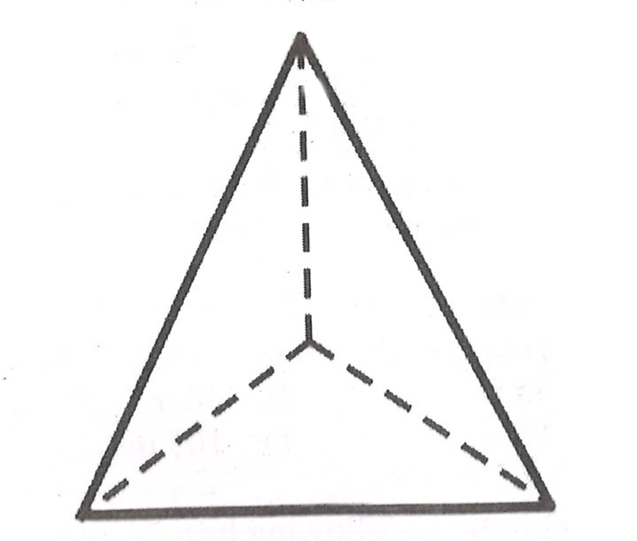
What is the name of the figure above?
A.
Cuboid
B.
Kite
C.
Triangle
D.
Pyramid

35.

13 | 12 | 17
E | F | 10
11 | 16 | G
Use the magic square above to answer the question below
Find the value of F.
A.
14
B.
15
C.
18
D.
23

36.

13 | 12 | 17
E | F | 10
11 | 16 | G
Use the magic square above to answer the question below
Find the value of E.
A.
14
B.
15
C.
18
D.
23

37.

13 | 12 | 17
E | F | 10
11 | 16 | G
Use the magic square above to answer the question below
Evaluate E + G.
A.
29
B.
30
C.
33
D.
38

38.

The hypotenuse and a side of a right-angled triangle are 13 cm and 5 cm respectively. Find the length of the third side.
A.
8 cm
B.
9 cm
C.
12 cm
D.
17 cm

39.

Find the missing number in the sequence below:
11,16,22,29,-,46,56.
A.
30
B.
36
C.
37
D.
39

40.

A hall which is 20 m long is represented on a diagram as 10 cm long. What is the scale of the diagram?
A.
1:200
B.
1:250
C.
1:400
D.
1:500

